The document contains screenshots of the **New Registration process**:

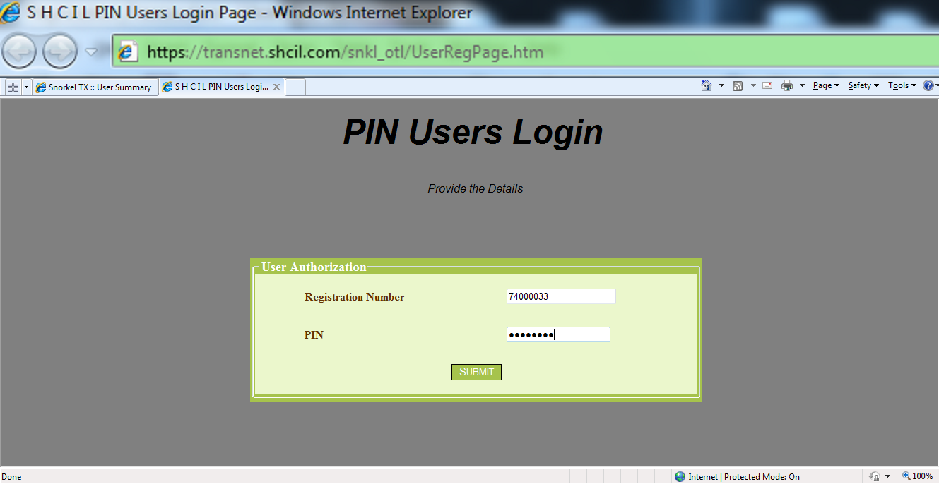1. Access the url <https://transnet.shcil.com/snkl_otl/UserRegPage.htm>

2. Click the “Next” button.

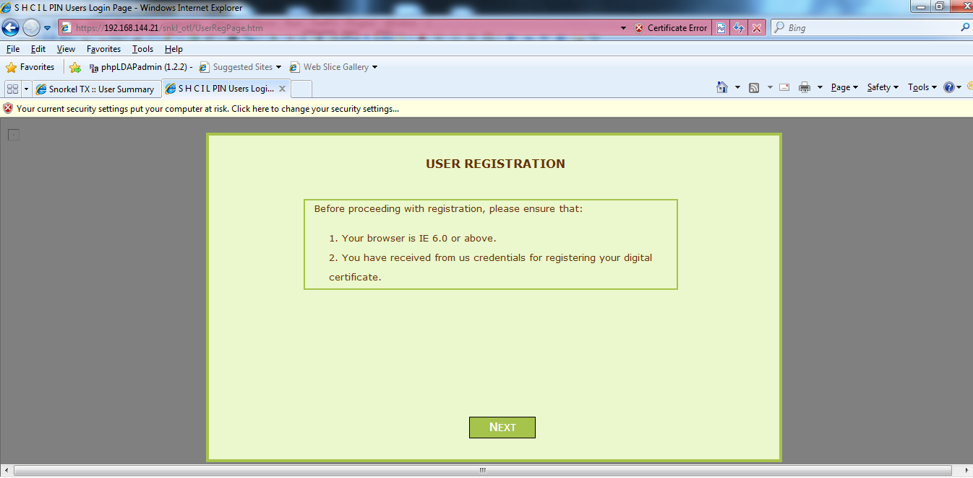

3. Fill the details which are empty if not proceed by clicking on the “Next” button.

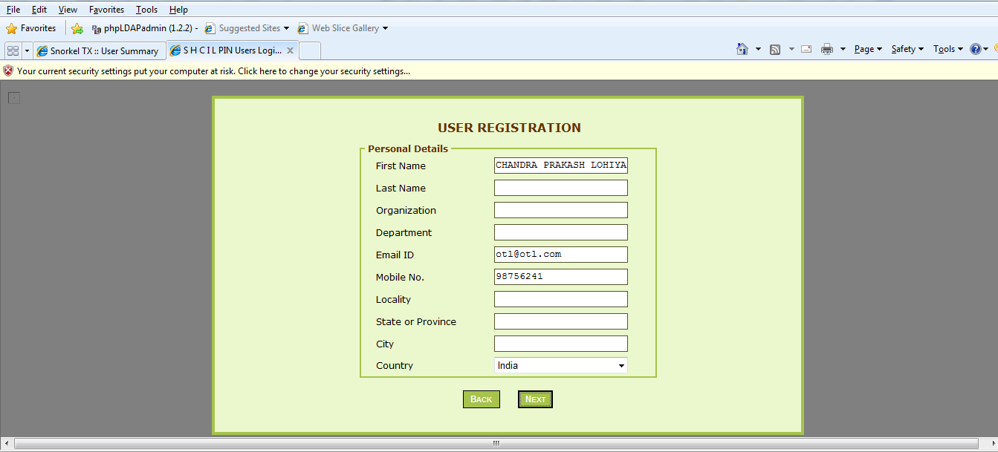

4. Answer the security Question and click Next.

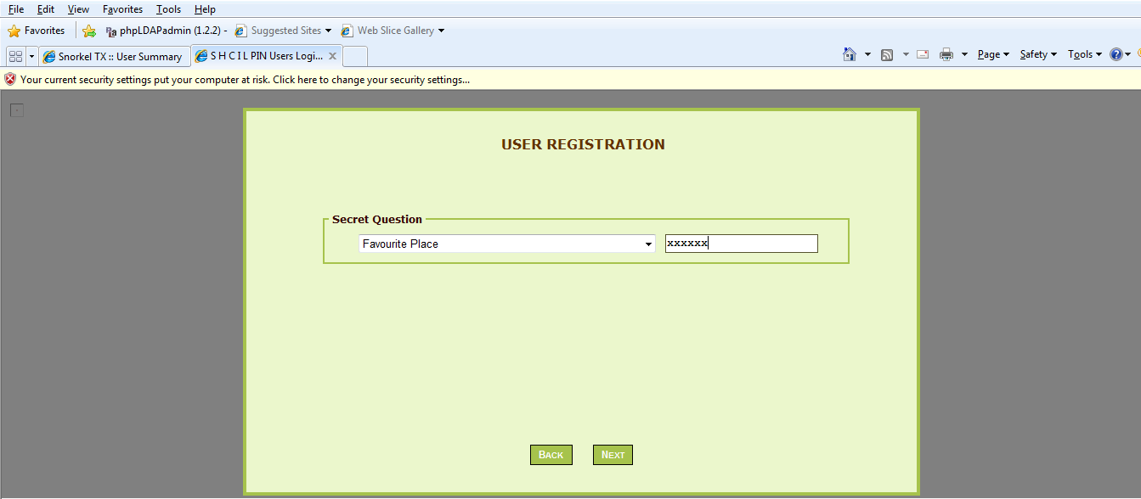

5. Choose the CSP as “Microsoft Enhanced Cryptographic Provider” and click on Register.

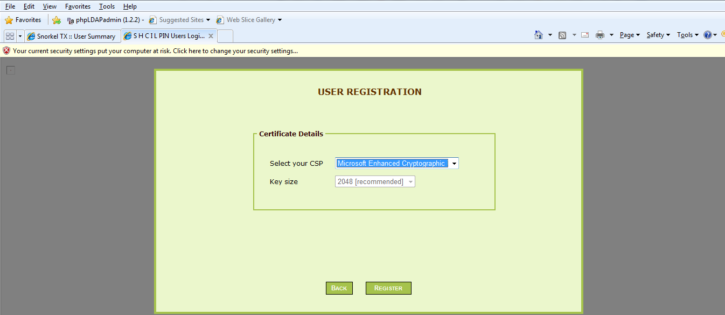

6. Click the “Set Security Level” button.

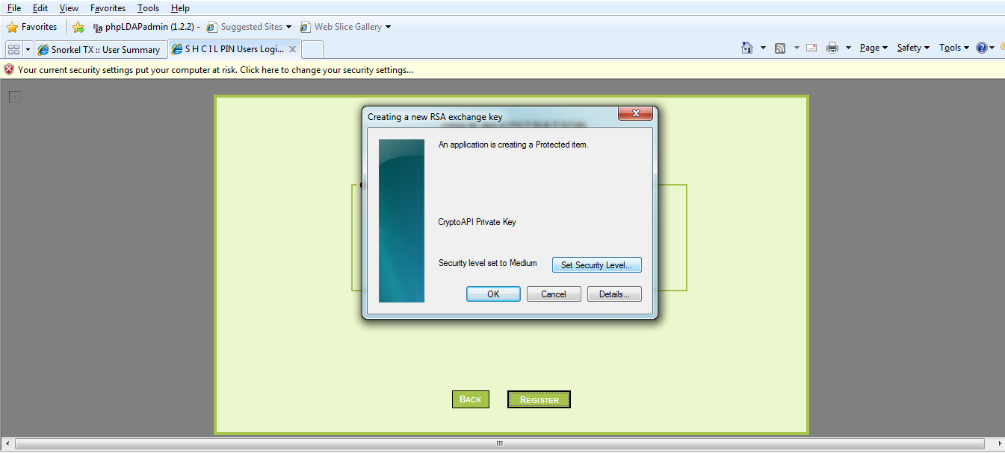

7. Set the security level as High and click on Next.

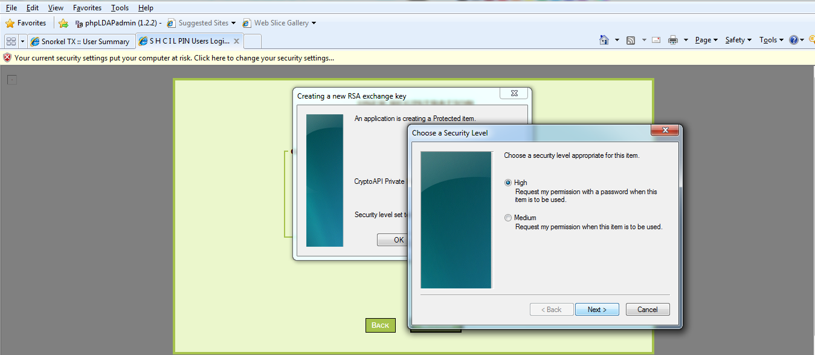

8. Enter password for the new Signing certificate which will be created in the Browser store.

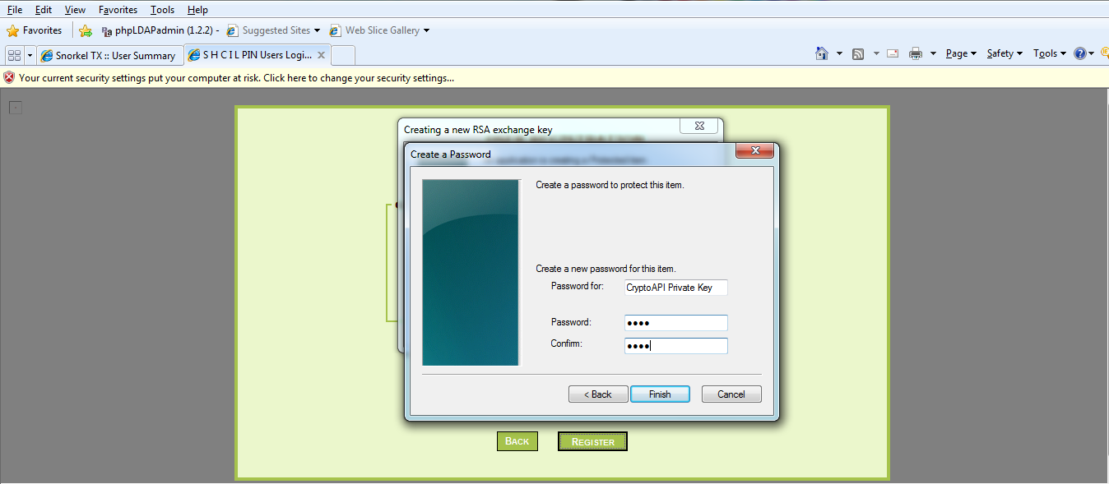

9. A prompt will be displayed to Sign data with the new signing certificate which got created.



10. Insert password of the signing certificate which was set before.

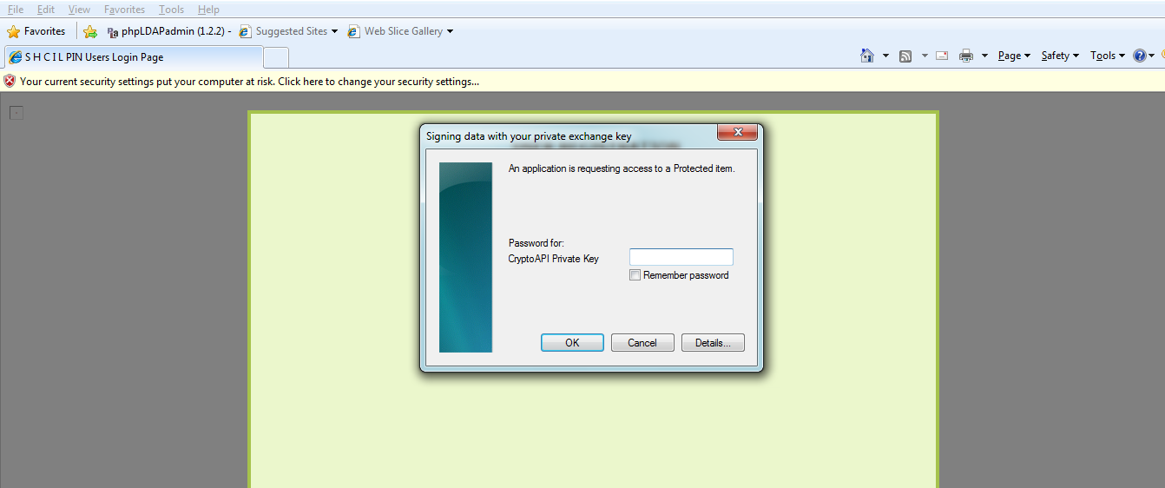

11. The following message will be displayed on successful registration process.

